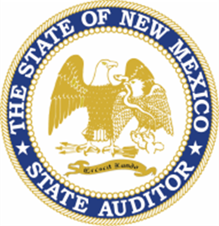 |  | NM Office of the State Auditor  Small Local Public Bodies  Fall Updates | October 2024 Issue #1
What’s New? |  | The latest news and announcements
OSA-Connect  Users can now electronically-sign contracts and tier certifications!  --  New instructional videos guide users through uploading tier certifications, creating AUP contracts, and more!  Watch here:  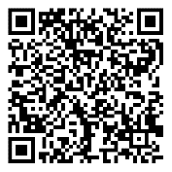  Contact us today!  Manuel Luna  Small LPB Coordinator  505-394-1600  Manuel.Luna@osa.nm.gov  --  Gabriella Gabaldon  Graduate School Intern  505-629-9484  Gabriella.Gabaldon@osa.nm.gov |  | Financial Assistance for Small Local Public Bodies  The OSA is pleased to announce the launch of the small Local Public Bodies assistance program. The OSA has partnered with local independent public accountants to assist LPB’s prepare and submit financial reports to meet reporting requirements per the Audit Rule and Audit Act. Please note that funding is limited and will be awarded based on need and availability.  Application  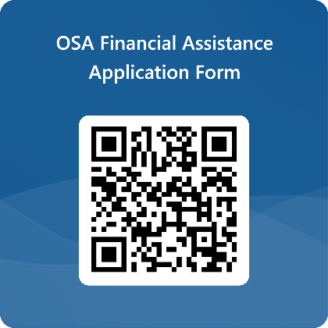  Small Local Public Bodies Training  Need training on how to upload Tier Certifications or contracts for AUPs? Or do you have questions about compliance to be eligible for capital outlay funding? We can bring the training to you and your community. Reach out to us and we will try our best to accommodate your needs.  

